# Design

## Workflow

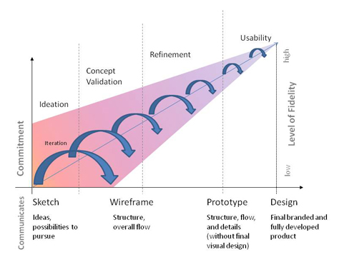Starting off for the design stage I need to decide on a workflow to coincide with my Modified Waterfall Method that has been chosen for development.

The figure on the right shows the structure of which the User Experience and Layout Design will be developed upon. **Commitment**, **Level of Fidelity** along with the different **Stages** (Sketch, Wireframe, Prototype and Design) must be kept in a balance as to allow for the optimal time efficiency, too much Commitment and Level of Fidelity should not be done in the first Stages as it will use up time better spent on the areas that need it. The project will be done as follows:

1. 6 & 1’s – Six Sketches will be drawn out each with their own separate layout of the elements needed on the page in order to narrow down the design to what is best, of which the seventh one will be more detailed and refined containing a more reliable and fitting UX and Design.
2. Prototype up the layout using an even greater Level of Fidelity.
3. Finalize the design and branding, code it up with HTML and CSS to get an actual visual on the intended project layout.
4. This process will then continue to develop alongside the Modified Waterfall Method and be re-iterated constantly as the project comes into being.

## 6 & 1’s – Main Page

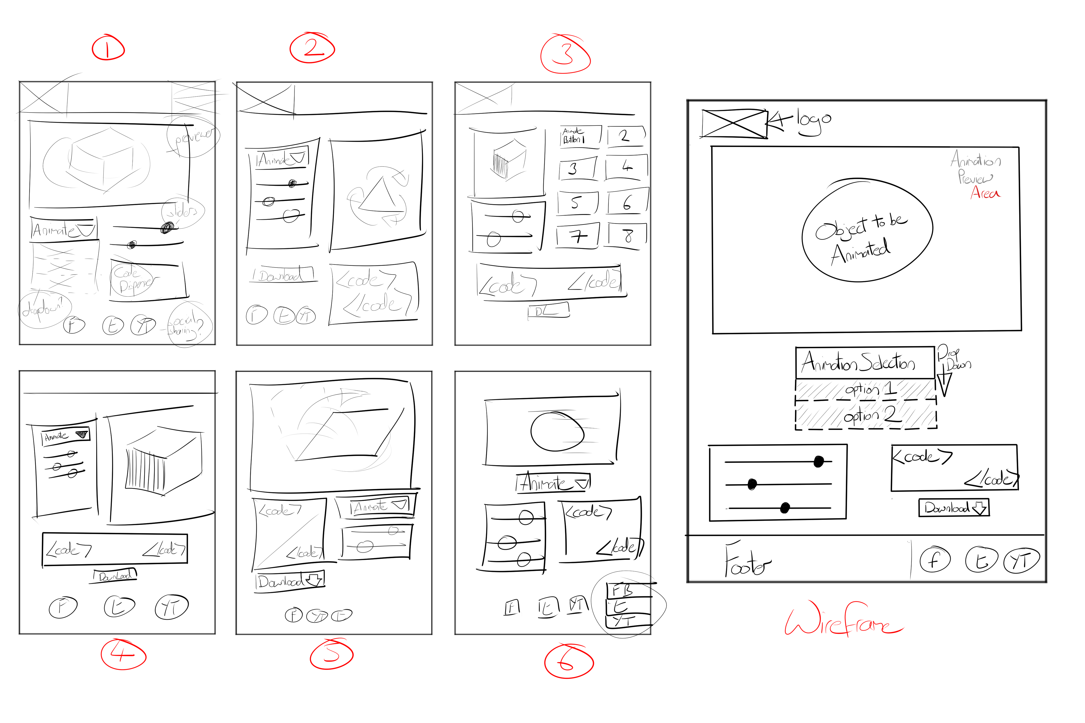

1. First sketch – has a header which would be used to house the logo image and a navigation to the site but was deemed unnecessary as there is not a strong need for multiple pages for this project and thus does not need to have a strong indicator to focus the user there. The main focal point is the Animation Previewer and how to operate it so having the two main elements for doing so just beneath helps to indicate to the user of its function and purpose. The code dispenser coming once again below the sliders to show the hierarchy of the elements.
2. Second Sketch – still contains the header, the sliders and animation selection has become an aside to the left of the Previewer perhaps allowing better ease of access to the controls and overall convenience in doing so. Code dispenser and the download for it come underneath but split into two parts. It starts to look a bit cluttered with more elements being put side by side and the feel for the product does not seem to resonate for this layout.
3. Third Sketch – taking into consideration some of the examples of real world uses for something along these lines, the layout was made with separate buttons which would trigger the Animation Preview on the left and the sliders to customize coming below that. The code dispenser is then made into full width to complete the design but overall this is not the style the project should go in, there is too much clutter and does not allow for much flexibility for future expansions to the choice of animation.
4. Fourth Sketch – joined up the animation selector and customizable sliders into one element in an aside similar to the second sketch, this time making the code dispenser full width and the download button below it in a smaller size creating an OK flow to the whole experience but it is not quite there yet.
5. Fifth Sketch – header is taken away in order to open up the white space a bit more and help to minimalize the layout a bit, the previewer is full width and is the first thing you see, below is the code dispenser followed by the animation selector and sliders. The positioning of the previewer is perfect but the other elements still do not have their placement quite right.
6. Sixth Sketch – there is now a more structured look to the way the elements are presented and an overall more minimal style. This is more in line with what is hoping to be achieved through this trial and error sketching process.
7. The Wireframe – I don’t include the header but I work the logo into the top left. The layout is taken from Sketch 6 and helps to define a hierarchy between the elements, the user will first see the previewer, then the animation selections followed by the sliders and code dispenser to create a triangle. The user can easily identify with what to do in order to operate the canvas and what specifically effects the other. The insertion of the footer is to possibly allow for some portfolio links and social media platforms, laid out in a clean compact way as to make its presence non-intrusive. Overall this is the along the lines in which the project is most suited, more iterations and polish will become apparent as development ensues.

## 6 & 1’s – Signup Page

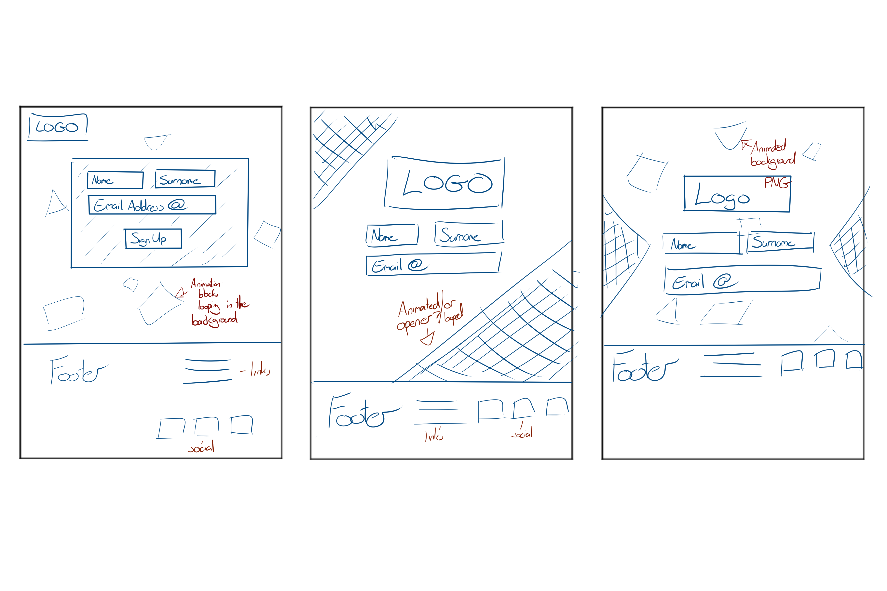

1. First Sketch – Simple setup with logo small situated at the top left of the page, whilst using a standard form layout inside a solid coloured box. There is an animated background looping on in the background which will help to give the user a sense of what this website is about and is going to offer them. The footer is standard with links and social media icons for shares.
2. Second Sketch – Trying to break away from the standard format of a signup page by enlarging the logo and placing it more predominately on the page, whilst opening up the form from a container and having diagonal shapes at each corner encapsulating the center page to draw more attention. The footer is laid out more inline this time to help compact and minimalize.
3. Third Sketch – The last sketch is one of a mix between the first two, taking on the enlarged logo, open form, triangles at the sides vaguely indicating towards the center page, animated background of floating shapes and the inline footer from the Second Sketch.

## Logo & Branding

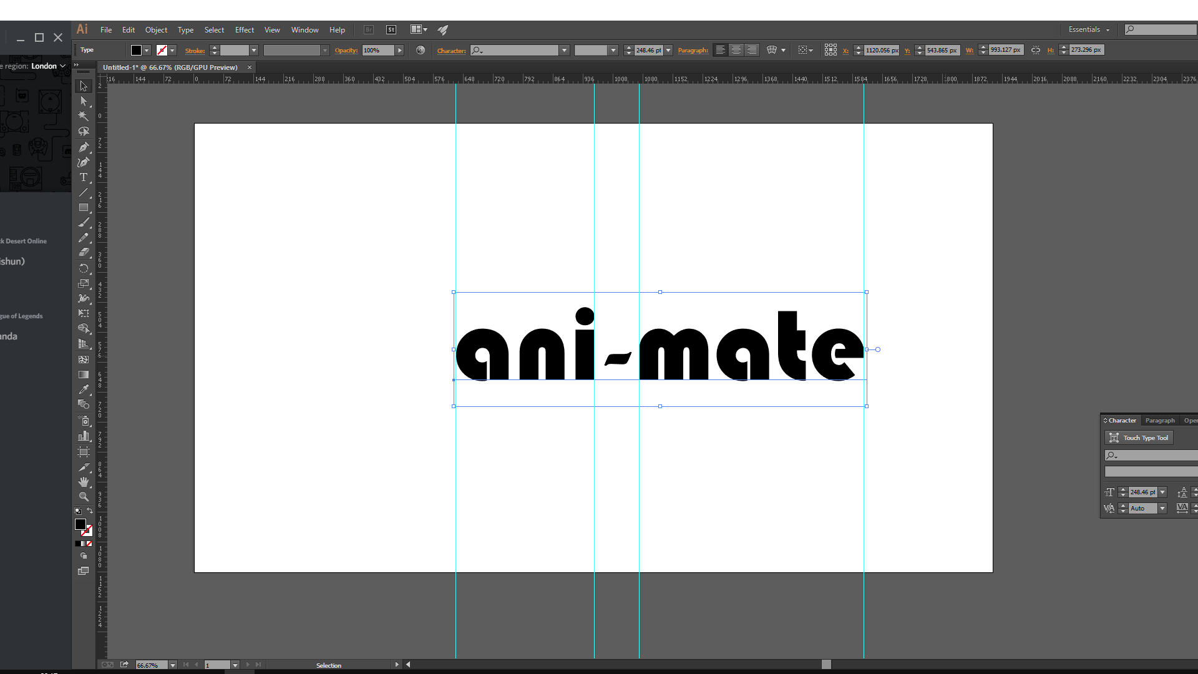

In order to further personalize and brand the project that is being made, it’s also in need of some character in order to define itself.

This is where the logo and branding come in. After going through a range of fonts for the logo, ultimately **Bauhaus 93** was chosen, which is a nice simple, clean geometric styled font that best suited the style and theme planned for the project.  
Two colours were also used as placeholder in order to help separate and distinguish the two parts of the logo name.

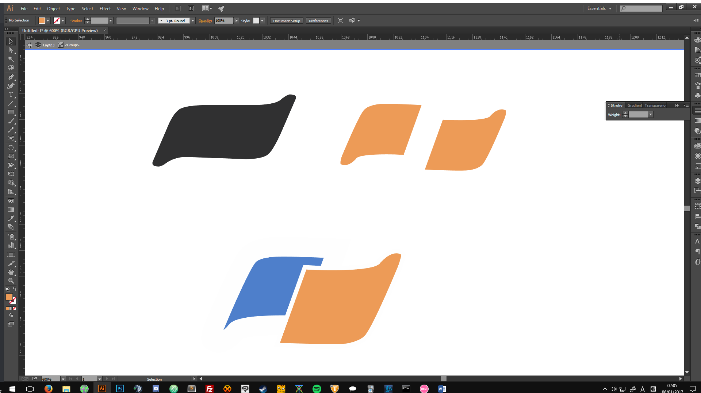

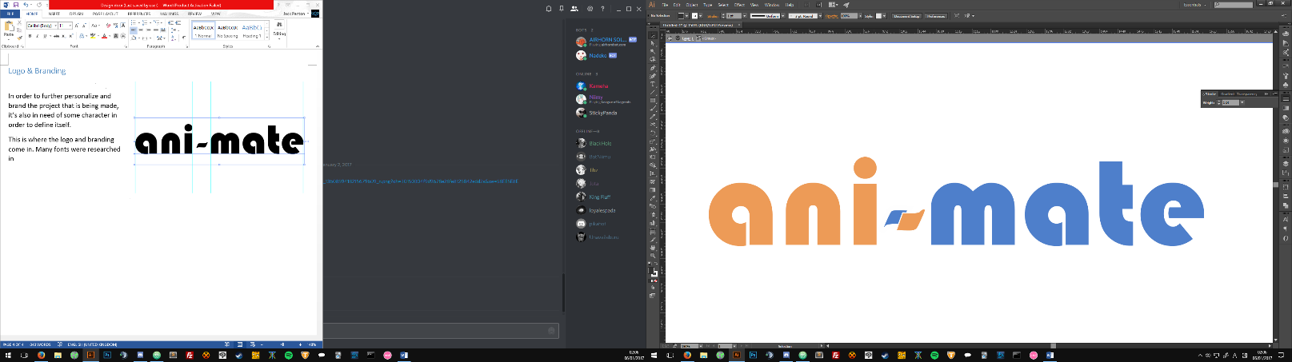Here was the first edition in the development of the logo brand, it started with playing around with two different colours to separate the word “animate” and using a hyphen to create a kind of trademark that could be a part of the actual logo name itself.

Overall it didn’t really feel fit the theme for what was trying to be accomplished for the feel and flow of the project.

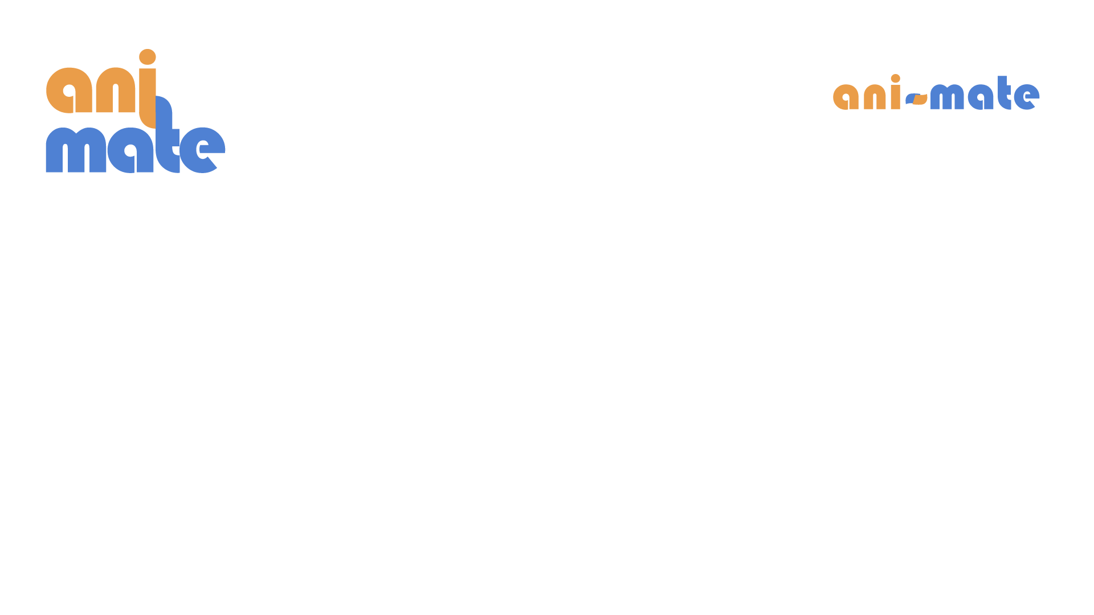

The second edition that was made felt a whole lot better in terms of what is being sought for within the logo design. Something simple, easily recognizable with a bit of a quirk to tie the two together. The compactness done via reducing the tracking between the characters also serves to enhance the logo.

## Artboards

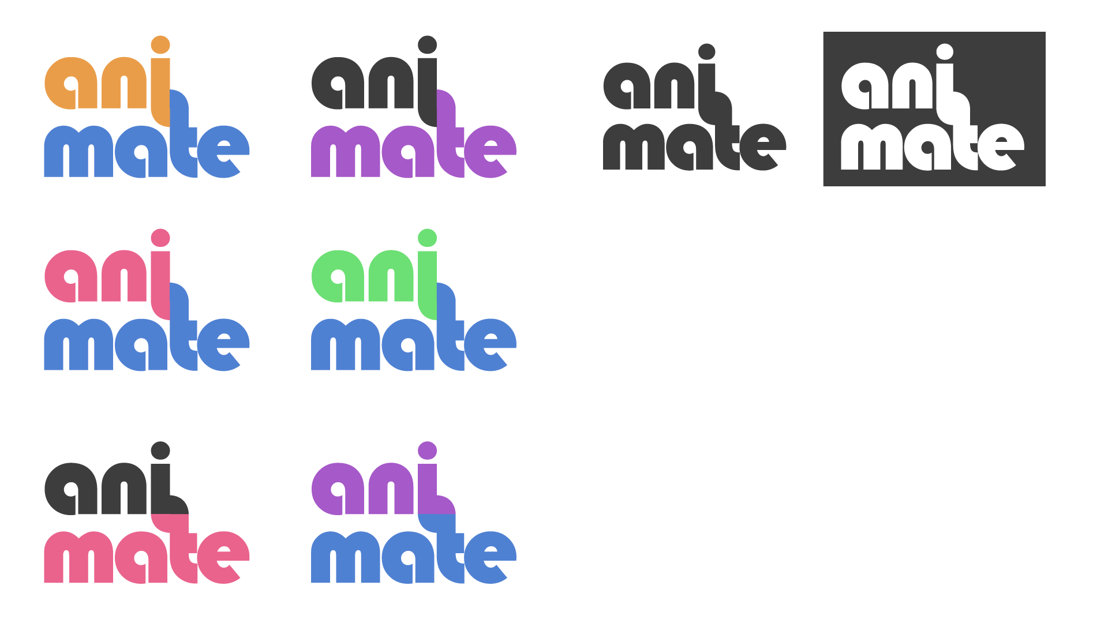

Above is an artboard drafting different colour combinations that may work with the logo along with doing some tweaks as you can see on the last two in order to check out another angle.